Name :- Kishan Lal
Course :- M.sc Digital Forensics & Information Security
Enrolment No. :- MSDFIS02
Subject :- Incident Response Management

Incident Response Management

Experiment :- 1

Title :- Installation and Demonstration of Nmap
Requirements :- Laptop and Active Internet connection
Objectives :- Scanning DVWA
Procedure :-
1) Open up the Terminal in your Linux machine
2) type `sudo dnf install nmap`
3) After installation scan the DVWA using `sudo namp -sS 192.168.95.141`

Results :-

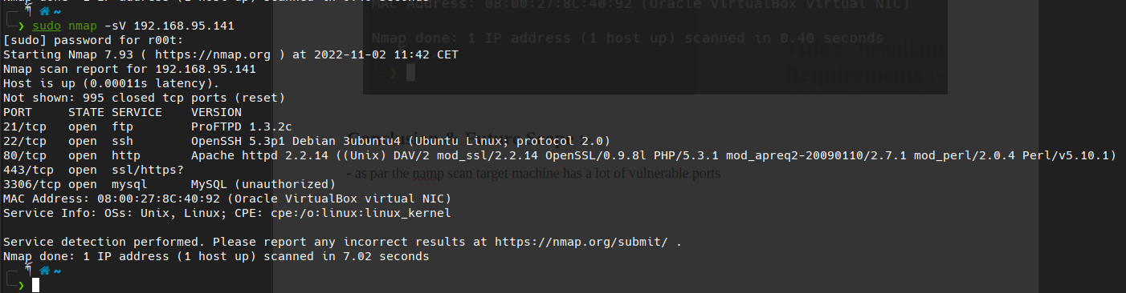

Conclusion & Future Scope :-

- as par the namp scan target machine has a lot of vulnerable services open to attack for example here we have the open port of 21/tcp ProFTPD 1.3.2c which is vulnerable to the Remote Code Execution here is the POC.

Incident Response Management

Experiment :- 2

Title :- Installation and Demonstration of WireShark
Requirements :- Laptop and Active Internet connection
Objectives :- Network Sniffing
Procedure :-
1) Open up the Terminal in your Linux machine.
2) type `sudo dnf install Wireshark`
3) After installation open up the Wireshark application and choose the interface.

Results :-

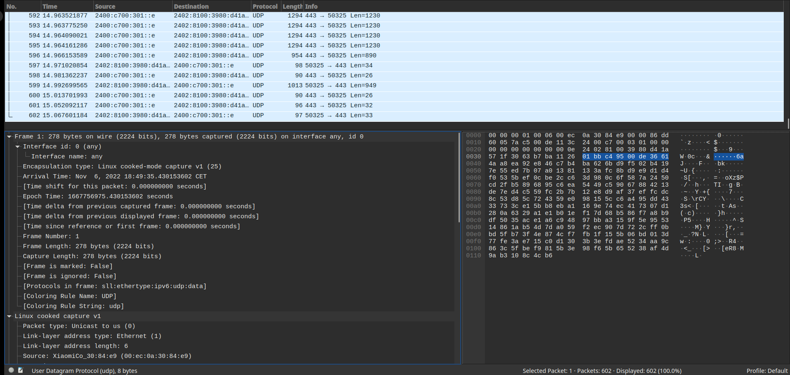

Conclusion & Future Scope :-

- as per the results we can see that through wireshark we can sniff the packets and analyse our network traffic.
- if we are performing the pen test against any company wireshark can help us find out if our tool are working find or not.

Incident Response Management

Experiment :- 3

Title :- Analyse and monitor system using event viewer
Requirements :- Windows OS
Objectives :- analysing our computer activities using event viewer
Procedure :-
1) Press the WIN-KEY + R
2) Type `eventvwr` in the Search Box

Results :-

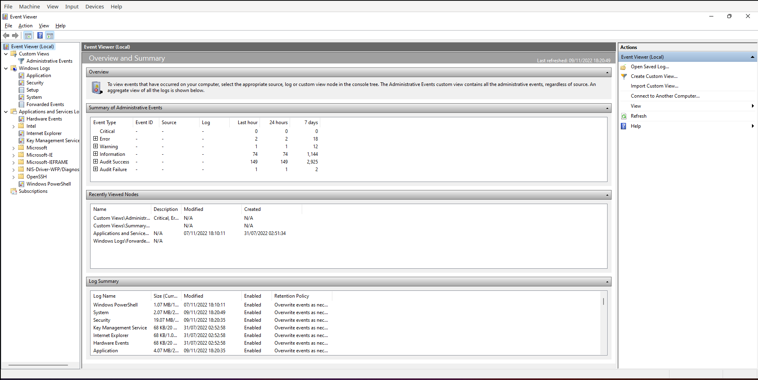

Conclusion & Future Scope :-

- as per the results we can say that event viewer displays detailed information about significant events on your computer. Some of the information you will find are programs that don't start as expected, or automatically downloaded updates.

Incident Response Management

Experiment :- 4

Title :- Installation and Demonstration of Sysinternal tools
Requirements :- Laptop with windows OS and Active Internet connection
Objectives :- analysing our computer activities using sysinternal tools
Procedure :-
1) Open up the `file explorer` in you windows OS
2) Right click on the `file explorer` and select the `add network location`
3) click on `next` and you will get asked to write the network address write this URL `https://live.sysinternals.com/`
4) click on `next` and boom !!
5) you will get one network drive called `live.sysinternals` there you can find all the sysinternals tools.

Results :-

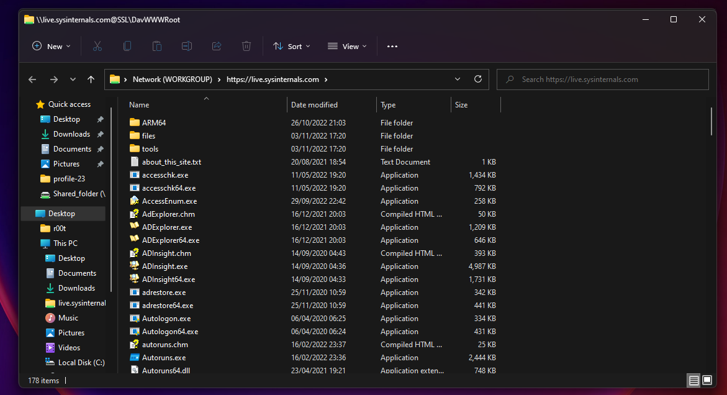

procmon64.exe

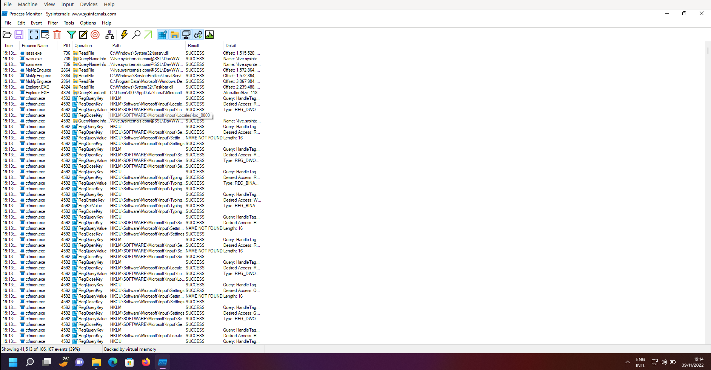

rammap64.exe

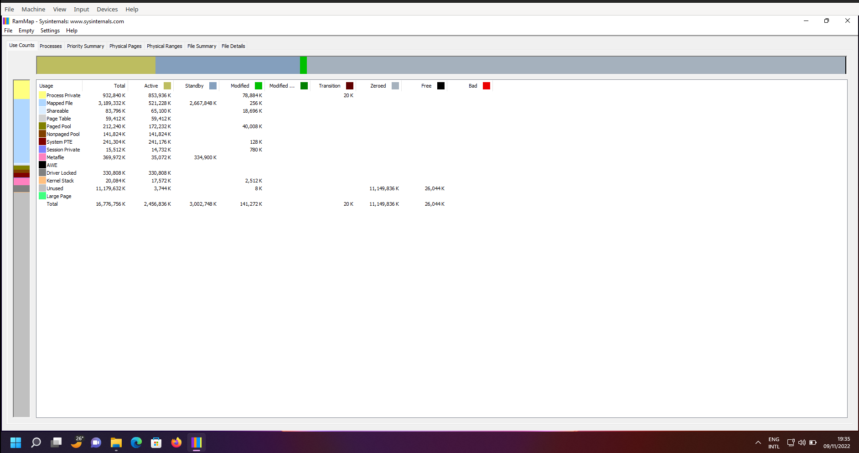

procexp64.exe

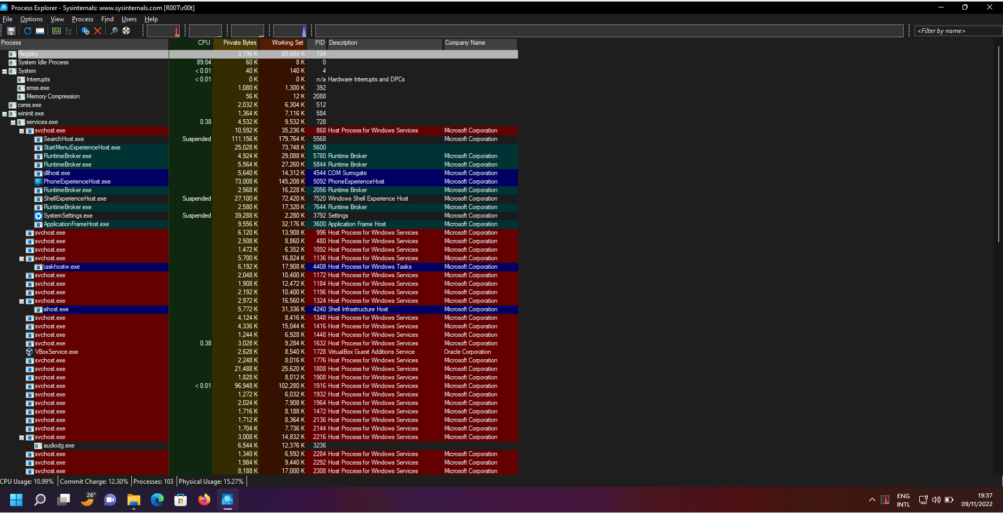

Diskview64.exe

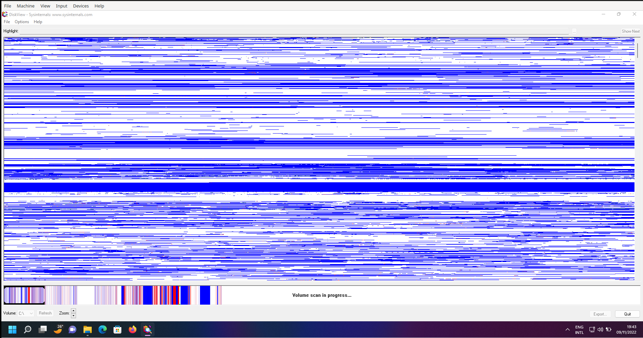

autoruns64.exe

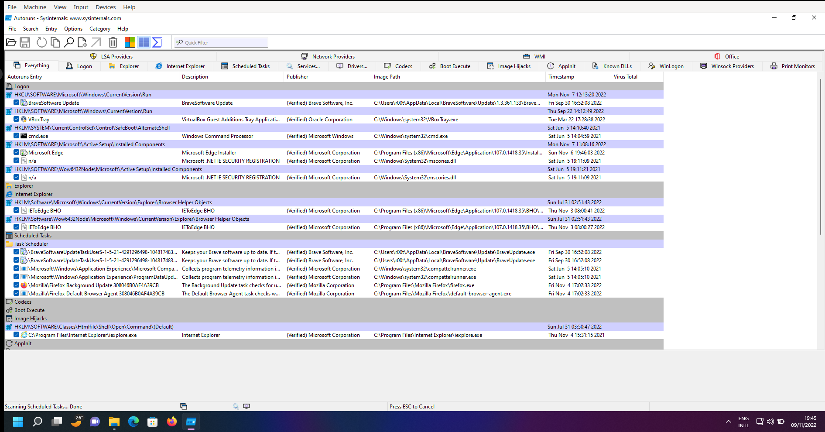

bginfo64.exe

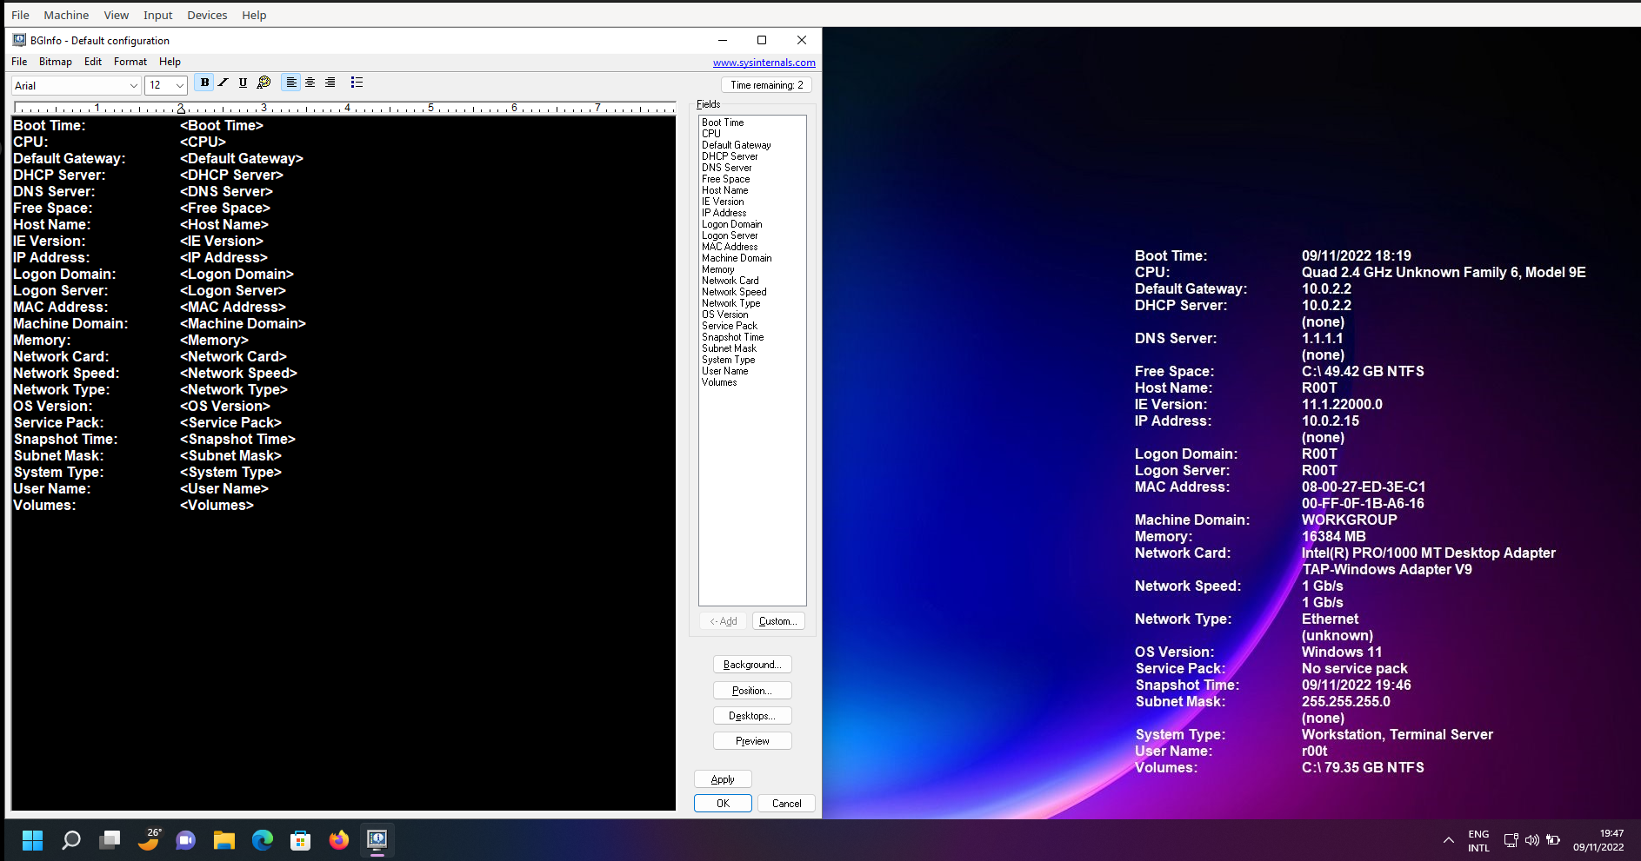

tcpview64.exe

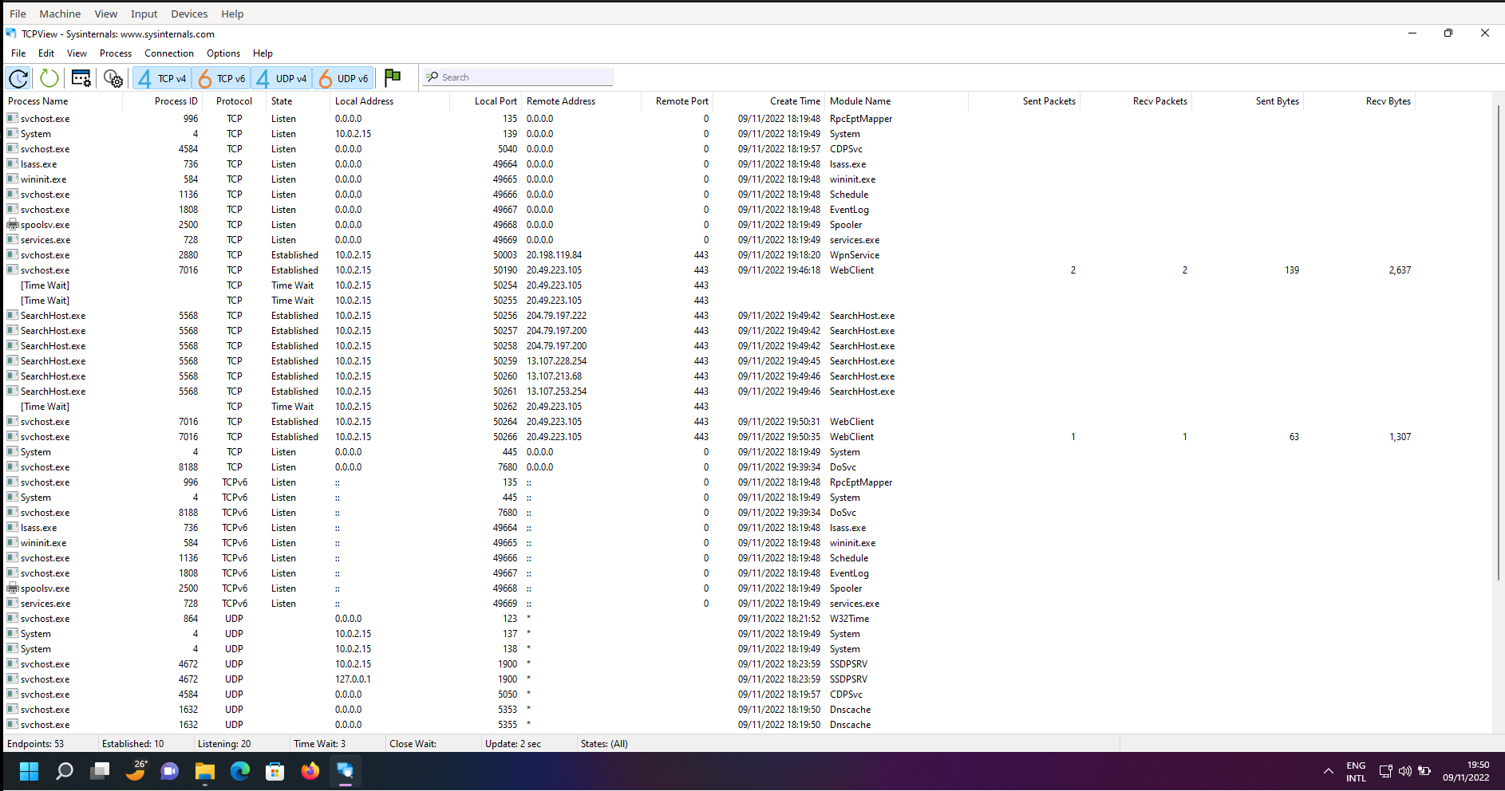

vmmap64.exe

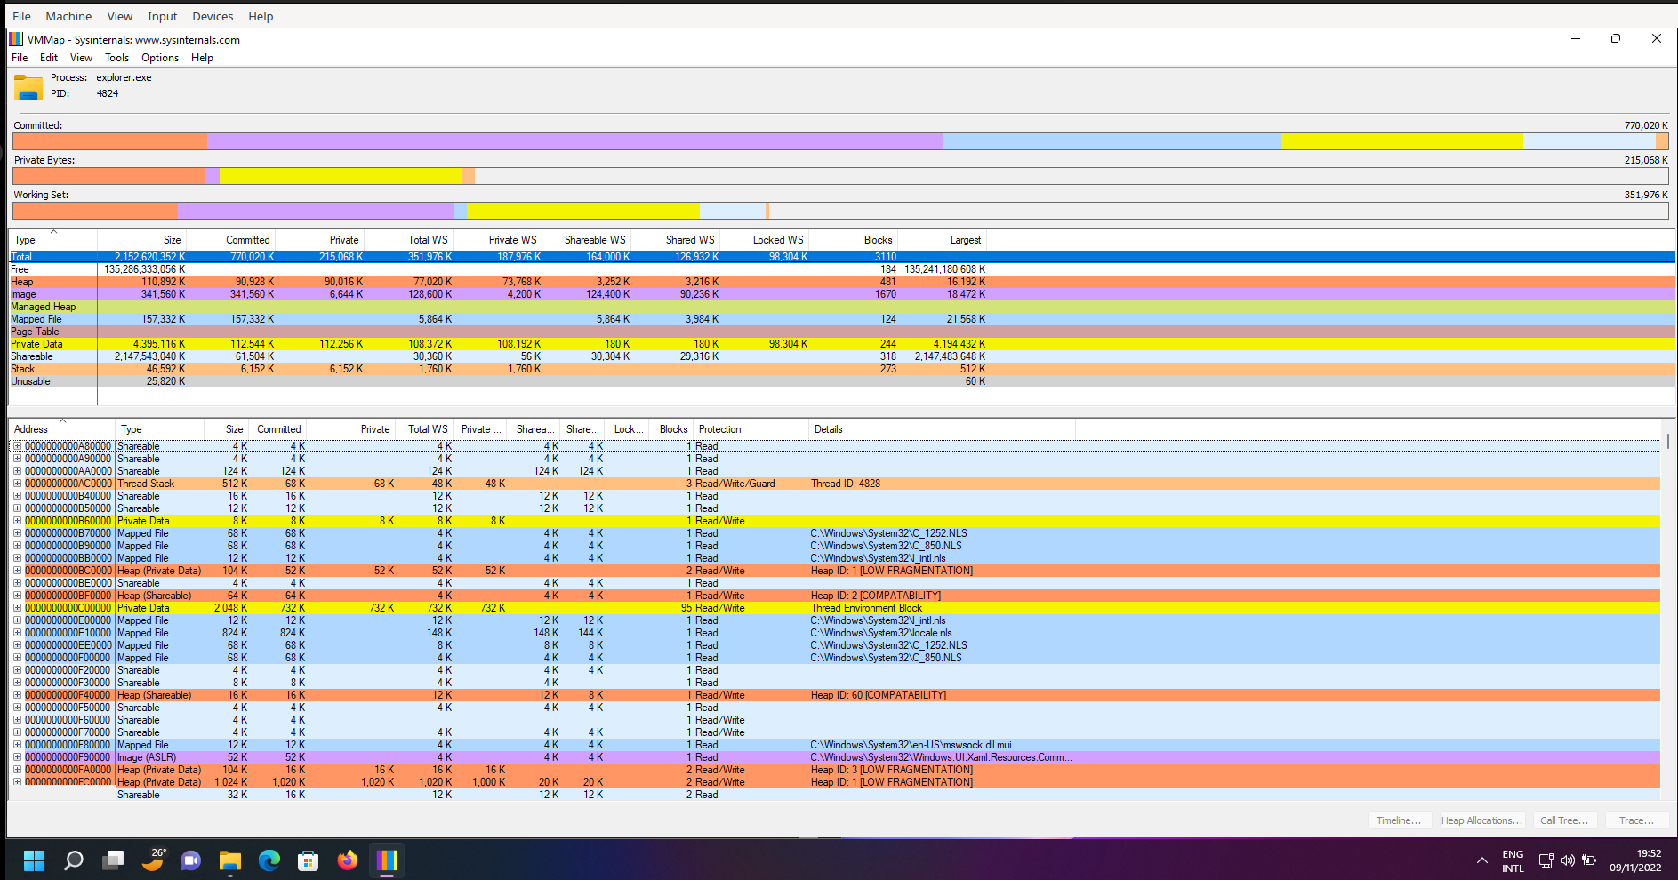

WinObj64.exe
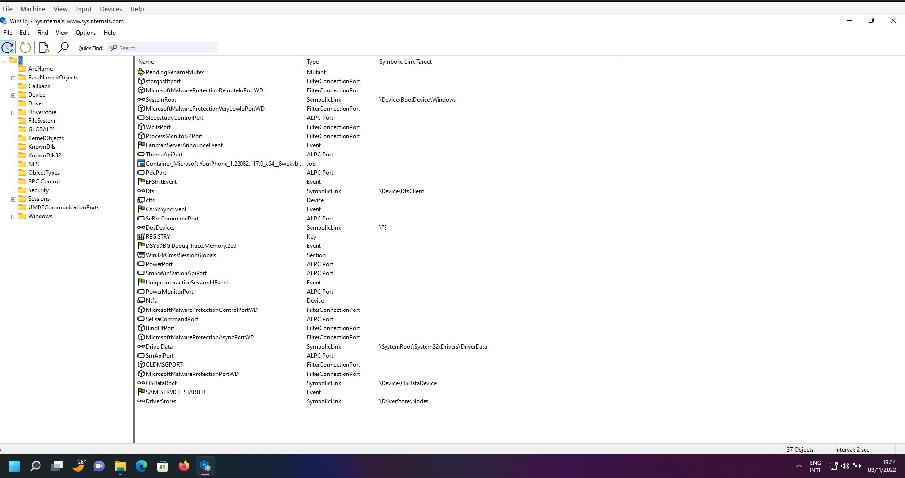

dbgview64.exe

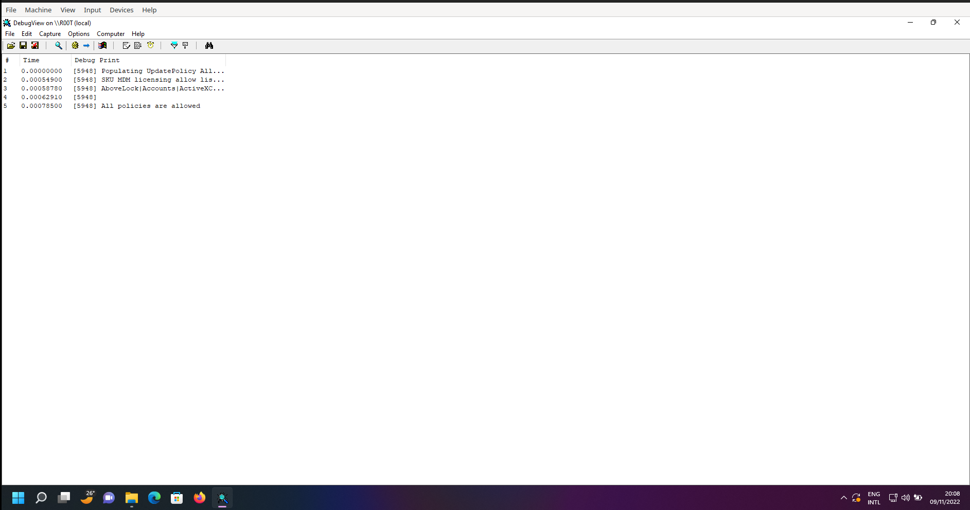

Conclusion & Future Scope :-

- as per the results and demonstration we can conclude that sysinternals suite helps administrators to see disk usage by directory, measure network performance, remotely execute processes, dump event log records and much more

Incident Response Management

Experiment :- 5

Title :- Installation and Demonstration of snort
Requirements :- Linux Laptop and Active Internet connection
Objectives :- Implementing IDS policies
Procedure :-
1) Open up the Terminal in your Linux machine
2) type `sudo dnf install snort`
3) go to the `/etc/snort/snort.conf` file here you can implement your own IDS/IPS rules

Results :-

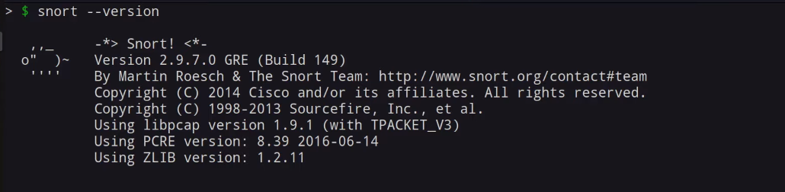

Conclusion & Future Scope :-

- as per the results we conclude that snort is a foremost open source intrusion prevention system in the world. Snort IPS uses a series of rules that help define malicious network activity and uses those rules to find packets that match against them and generates alerts for users.

